Use-Case Realization Report
AddCustomer

Issue <1.0>
Revision History
Date | Issue | Description | Author
<02/08/09> | <1.0> | <AddCustomer> | <Karen Gao>

Table of Contents
1. Brief Description 4
2. Flow of Events 4
2.1 Standard Flow 4
2.2 Exceptions 4
3. Interaction Diagrams 5
3.1 Collaboration Diagram for Add Customer 5
4. Participating Objects 5
5. Class Diagrams 6
5.1 Class Diagram for Add Customer 6
6. Derived Requirements 6

Use-Case Realization Report
AddCustomer

Brief Description
The creation of a new customer record shall be executed once the validation and duplication of the existing customer list was performed.

Flow of Events

Standard Flow
This use case covers the events of adding Customer, which is part of the customer maintenance package. The standard flow of events is described as below:
- The Portal Administrator shall press the button to send out a command of “AddButtonClicked” on the interface of CustomerPage.
- Once the Customer Controller received this request, it will perform the check Customer operation.
- The customer controller will get the customer list from object of customer.
- Next, the customer controller shall check for duplication of record, if not duplication of record is found, it will proceed to the AddCustomer action and perform and update the AddCustomerList.
- The new customer shall be shown on the Customer Page after successful addition.

Exceptions
- If the customer information submitted is invalid, the system will pop a warning message of “Invalid Customer” to the portal administrator.
- If a duplicate record is found, it will pop up a message of Customer Duplicate message.

Interaction Diagrams

Collaboration Diagram for Add Customer
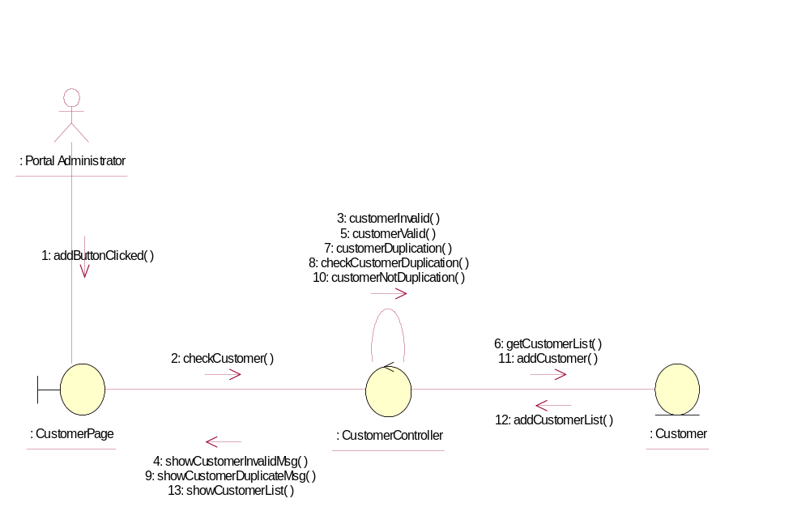

Participating Objects
: Customer

This Entity is Customer object

: CustomerController
This controller is to add, delete and update customer

: CustomerPage
This is a page for adding, deleting, updating and displaying the customer

: Portal Administrator
This is the super user of the system.

Class Diagrams

Class Diagram for Add Customer
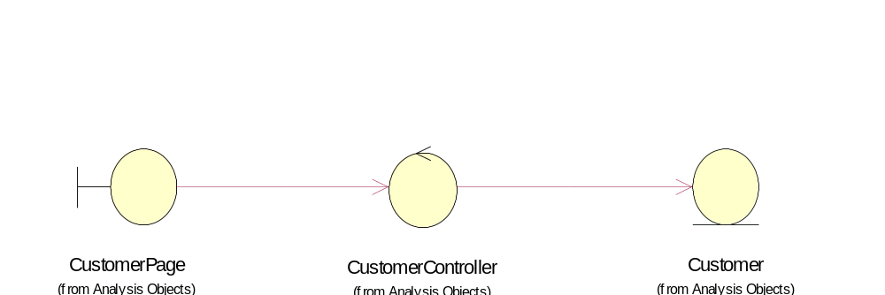

Derived Requirements
Only Portal Administrator can access this page.

